RC Receiver Pin list and interconnections between RC Shield and C2

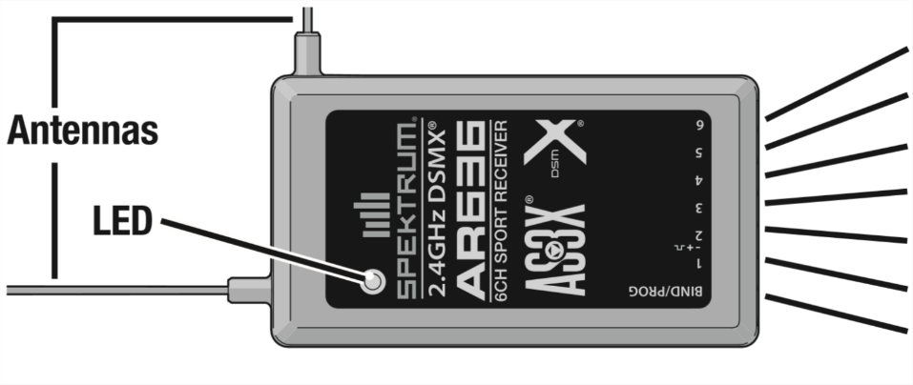  
**7.   
6.   
5.   
4.   
3.   
2.   
1.**



|  |  |  |  |
| --- | --- | --- | --- |
| **Receiver Pin #** | **Arduino Pin #** | **RC Controller Function** | **Programmed Trike Func.** |
| 1 |  | --- |  |
| 2 | 18 | Left Stick Up/Down | Brake |
| 3 | 21 | Right Stick Left/Right | steering |
| 4 | 19 | Right Stick Up/Down | RC Go |
| 5 |  | --- |  |
| 6 | 20 | E-Stop | E-Stop |
| 7 | (17) maybe | Flap/Gyro | --- |

**RC Shield Shematic and visual explaination:**

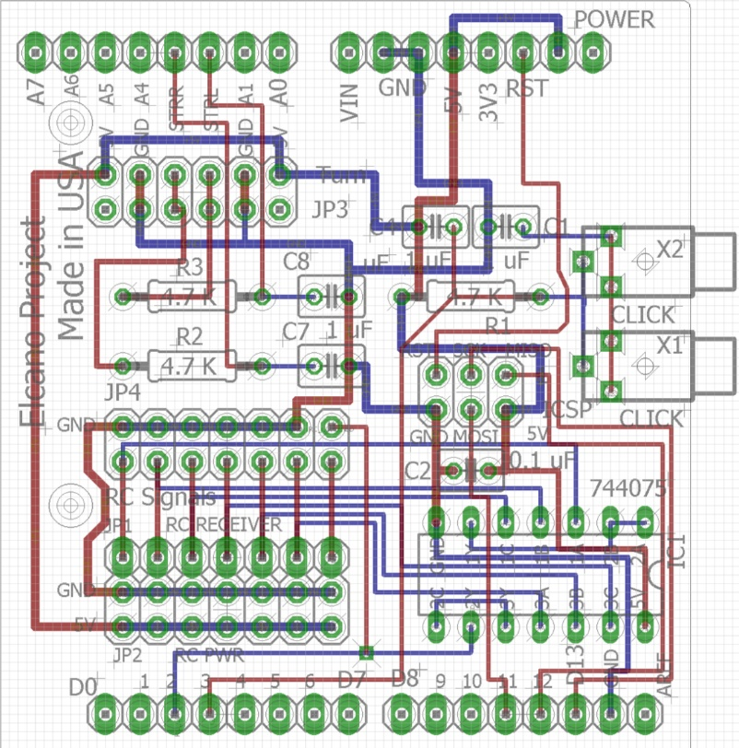

**1**

**22**

**32**

**42**

**52**

**6**

**72**

**72**

**6**

**52**

**42**

**32**

**22**

**1**

Jumper plug-ins (to Arduino)

RC Receiver plug-in